2BHK Independent Home on Sale at Badangpet

**Key features**

* Clear Title
* Built with 100% as per vastu
* 163 S.Yards Plot with 30X45 feet Slab area
* High quality L&T Cement used for entire construction
* High quality lightweight brick used
* Borewell facility
* Very big sump with drinking water and regular water separation at both sump and storage
* Newly completed resurfacing of entire slab for a stronger and leak free home
* Designed by reputed architect to support G+3 construction in mind
* Marble Flooring
* Teak wood
* Beautiful and peaceful locality
* Lappam finishing
* Granite platform in Kitchen
* Up to date with all the property tax, electricity and water dues.

**Location Highlights**

* 100 meters to proposed Radial Road No 26 to ORR
* 5 Minutes to Mount Carmel Global School, Dilsukhnagar Public School
* 10 minutes to Apollo DRDO 12 minutes to DLRL, DRDO, BDL, and RCI
* 12 minutes to Adibatla Aero space Hub
* 20 minutes to International Airport
* 20 minutes to South India’s First Gold Refinery To Come Up In Kongara Kalan
* 30 minutes to Wonderla, FabCity, Pharma City

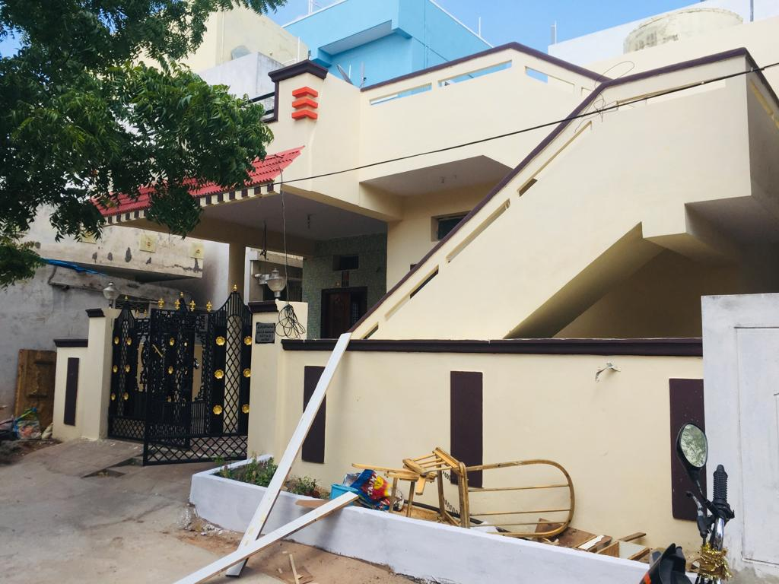

Google Maps Link:

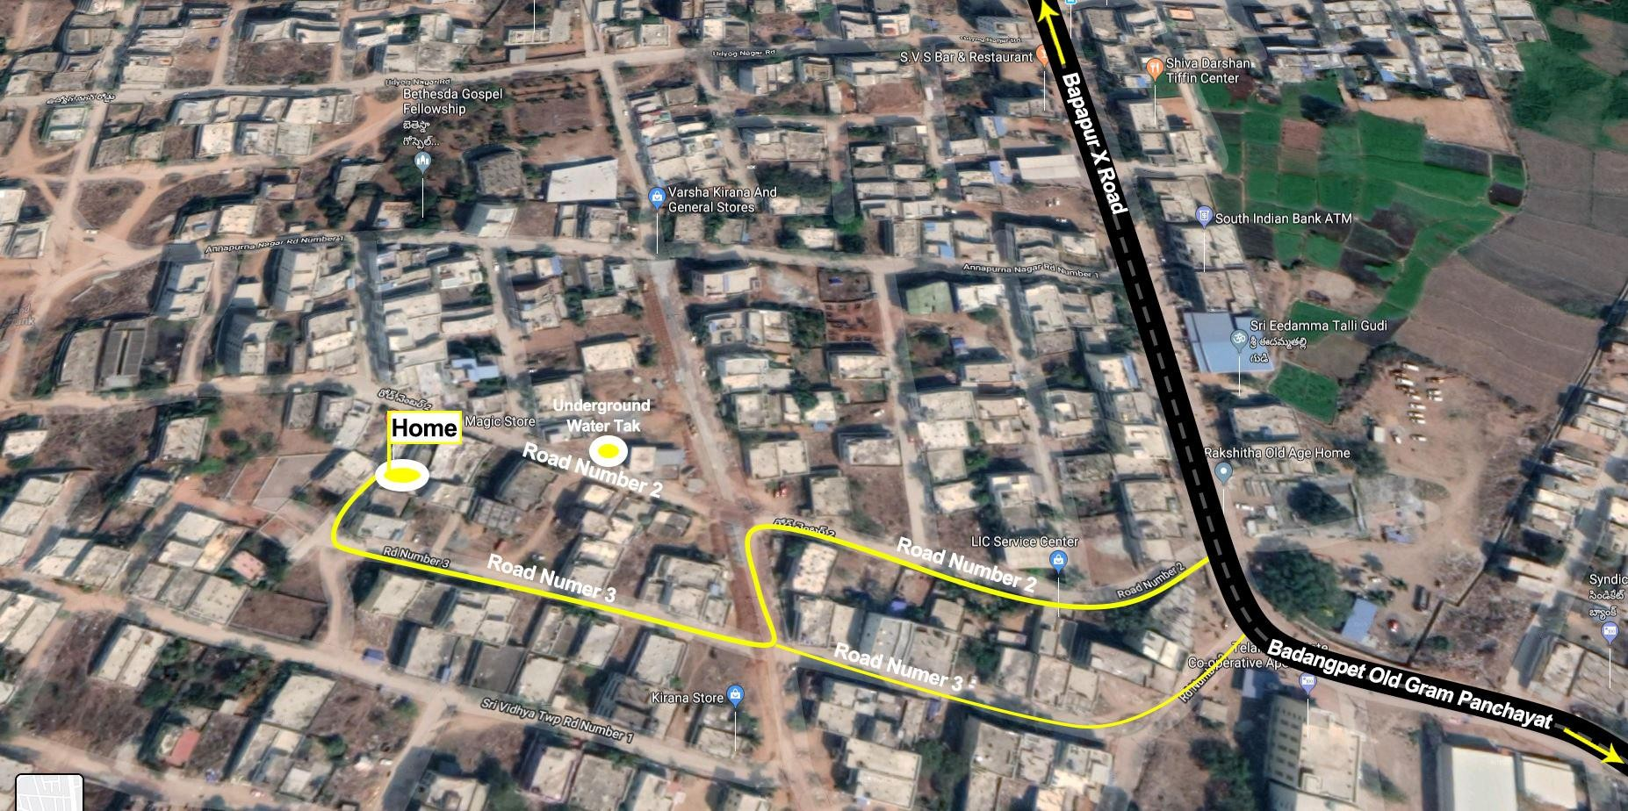<https://goo.gl/maps/MtvqUb4ZH5JBuY8C6>

**Contact:**

* Phone (India): RMS Rao +9912394125/+918897963425
* Phone (US): Surya Rayarao +1 573 616 9203 (Available on Whatsapp)

**Website:**For more information visit this this website:<http://myhomebadangpet.com/>

Photos

